AI-Enhanced Expense Tracking System

BACHELOR OF TECHNOLOGY

In
DEPARTMENT OF COMPUTER SCIENCE ENGINNERING
By
Srivathsava Reddy — 2420030634
R Sai Charan — 2420030140

Under the Esteemed Guidance of

Dr Neelima





K L (Deemed to be) University
DEPARTMENT OF COMPUTER SCIENCE ENGINEERING

DECLARATION

The Mini Project Report entitled “AI-Enhanced Expense Tracking System” is a record of bonafide work carried out by Srivathsava Reddy – 2420030634 and R Sai Charan – 2420030140, submitted in partial fulfillment of the requirements for the award of the degree of Bachelor of Technology in Computer Science and Engineering at K L (Deemed to be) University. The work presented in this report is original and has not been copied from any other department, university, or institute.

Srivathsava Reddy — 2420030634
R Sai Charan — 2420030140

K L (Deemed to be) University
DEPARTMENT OF COMPUTER SCIENCE ENGINEERING

CERTIFICATE

This is to certify that the mini project report entitled “AI-Enhanced Expense Tracking System” is a bonafide work carried out and submitted by Srivathsava Reddy – 2420030634 and R Sai Charan – 2420030140 in partial fulfillment of the requirements for the award of the degree of Bachelor of Technology in Computer Science and Engineering at K L (Deemed to be) University during the academic year 2026–2027, under the guidance of Dr. Neelima Gogineni, Professor, Department of Computer Science and Engineering, KLH Bowrampet Campus.

Signature of the Course Co-ordinator Signature of HOD

ACKNOWLEDGEMENT

We express our sincere gratitude to everyone who supported and guided us in completing our mini project, “AI-Enhanced Expense Tracking System.”
We would like to express our heartfelt thanks to our project guide, Dr. Neelima Gogineni, Professor, Department of Computer Science and Engineering, KLH Bowrampet Campus, for her valuable guidance, encouragement, and support throughout the development of this project.

We express our gratitude to Dr. P.Venkateshwar Sir (CSE)/Dr. Kaja Shareef Sir (CSIT), Head of the Department for Computer Science Engineering/ Department for Computer Science and Information Technology for providing us with adequate facilities, ways and means by which we are able to complete this project-based Lab.

We thank all the members of teaching and non-teaching staff members, and also who have assisted me directly or indirectly for successful completion of this project. Finally, I sincerely thank my parents, friends and classmates for their kind help and cooperation during my work.

Srivathsava Reddy — 2420030634
R Sai Charan — 2420030140

TABLE OF CONTENTS

S.No. | Contents | Page no.
1. | Abstract
2. | Introduction
3. | Literature survey
4. | Problem Statement and Objectives
5. | Hardware and Software requirements
6. | Implementation
7. | Results & Discussion
8. | Conclusion & Future Scope
9. | References

- ABSTRACT

The AI-Enhanced Expense Tracking System is a web-based application designed to help users record, manage, and monitor their daily expenses efficiently. The system enables users to add, update, delete, and view expense records containing details such as amount, description, date, and category. It provides a dashboard for viewing total expenses, monthly spending, and category-wise expenditure. An AI-assisted feature suggests suitable expense categories based on transaction descriptions and helps identify spending patterns. Users can also set monthly budgets and monitor their expenditure against predefined limits.
The application follows a microservices architecture using Spring Boot, with separate services for user management, expense management, and AI-based analysis. REST APIs facilitate communication between services, while JWT authentication supports secure login and access control. Eureka and Spring Cloud Gateway are used for service discovery and request routing. Each service is designed to maintain its own database. Postman supports API testing, GitHub Actions supports CI/CD automation, and Semgrep supports security analysis. Jira is used for task management, and Lucidchart AI is used for architecture design.
The primary aim of the project is to reduce the effort involved in manual expense categorization, improve spending visibility, and provide basic AI-assisted financial insights. The proposed system demonstrates the application of artificial intelligence and microservices in developing a maintainable and user-friendly expense management platform.
Team Name: Batch 16

Team Logo (if any):

Team Members:
->Srivathsava Reddy — University ID: 2420030634
->R Sai Charan — University ID: 2420030140
- INTRODUCTION

Managing daily expenses is an important part of personal financial planning. People spend money on various activities, including food, transportation, shopping, education, bills, and entertainment. Maintaining these records manually can be time-consuming and may lead to forgotten transactions, incorrect entries, and difficulty in identifying spending patterns.
The AI-Enhanced Expense Tracking System is proposed to simplify expense management through a centralized web-based platform. It allows users to maintain expense records, organize transactions into categories, view monthly expenditure, and monitor their budgets. The dashboard presents financial information in a structured manner so that users can understand their spending habits more easily.
An important feature of the proposed system is AI-assisted expense categorization. Based on the description entered by the user, the system suggests a suitable category. It also aims to analyze expense history and provide basic spending insights, such as identifying high-expenditure categories and possible budget overruns.
The backend follows a microservices architecture using Spring Boot. The major services are User Service, Expense Service, and AI Service. REST APIs enable communication between the frontend and backend services. JWT authentication is used for access control, while Eureka and Spring Cloud Gateway support service discovery and request routing.
The project aims to combine expense management, budget monitoring, interactive reports, and AI-assisted analysis in a single application. The following sections describe the related systems, problem statement, objectives, requirements, implementation approach, results, conclusion, future scope, and references.

- LITERATURE SURVEY
The following related platforms can be used to study existing expense management and budgeting solutions. Each entry explains the platform's purpose and its relevance to your project.

3.1 Walnut — Expense Tracking
Walnut is a personal finance application associated with expense tracking and transaction management. Expense tracking tools help users organize spending information and review their financial activities. Such applications provide a useful foundation for understanding how users record and categorize transactions. The proposed project extends this general approach by incorporating AI-assisted category suggestions and a microservices-based backend.
Reference: Walnut website.

3.2 Money Manager — Personal Finance Management
Money Manager is a personal finance management application that helps users record income and expenses and review their financial position. Its budgeting and reporting concepts are relevant to applications that organize transactions into categories and periods. The proposed system similarly focuses on expense records, monthly spending summaries, and budget monitoring, with additional AI-assisted insights.
Reference: Realbyte / Money Manager.

3.3 Wallet by BudgetBakers — Budgeting and Reports
Wallet by BudgetBakers provides personal finance and budgeting features that help users monitor spending and manage financial goals. Budgeting tools can make it easier to compare expenditure against planned limits and understand spending habits. The proposed project follows a similar financial management objective while exploring AI-assisted categorization and modular service integration.
Reference: BudgetBakers website.

3.4 YNAB — You Need A Budget
YNAB is a budgeting platform focused on helping users plan their money and manage spending according to financial goals. Its budgeting approach illustrates the importance of connecting expense records with spending plans. The proposed project includes monthly budget monitoring and aims to provide additional assistance through expense-description categorization and basic spending insights.
Reference: YNAB website.

3.5 Goodbudget — Household Budgeting
Goodbudget is a budgeting application based on allocating money to spending categories. It illustrates how category-based planning can help users control expenditure and track their financial goals. The proposed project also organizes expenses into categories and supports monthly budget monitoring, with an emphasis on automated category suggestions.
Reference: Goodbudget website.

3.6 Expensify — Expense Management
Expensify provides expense management capabilities, including transaction processing and receipt-related workflows. Such systems demonstrate the value of reducing manual effort when maintaining financial records. The proposed project addresses a related challenge through simple expense entry, category suggestions, and dashboard-based spending analysis.
Reference: Expensify website.

3.7 Zoho Expense — Expense Reporting
Zoho Expense is an expense management platform designed to support expense recording, reporting, and related financial workflows. Its reporting features are relevant to understanding how transaction information can be organized for review. The proposed project applies related reporting concepts to personal expenses and adds AI-assisted categorization and budget insights.
Reference: Zoho Expense website.

3.8 Splitwise — Shared Expense Management
Splitwise helps users record and organize shared expenses and calculate balances among individuals. It demonstrates the usefulness of structured expense records and automated calculations. Although the proposed system focuses on individual expense tracking rather than shared balances, both systems illustrate how software can reduce manual financial calculations.
Reference: Splitwise website.

3.9 Mint — Personal Finance Tracking (Historical Reference)
Mint was a personal finance platform that helped users view and organize financial information. Its historical approach to consolidating financial data provides context for the development of personal finance dashboards. Mint was discontinued as a standalone service in 2024, so it should be treated as a historical example rather than a currently available alternative.
Reference: Mint website.

3.10 Proposed AI-Enhanced Expense Tracking System
The proposed system combines expense CRUD operations, category-wise summaries, monthly budget monitoring, AI-assisted categorization, and spending insights. Unlike a basic record-keeping application, it aims to assist users in interpreting their expenditure. The use of separate Spring Boot services for user management, expense management, and AI analysis supports modular development and future extension.
Literature survey gap: These platforms demonstrate expense tracking, budgeting, reporting, or related financial workflows. Your project proposes combining these core functions with AI-assisted categorization and insights in a microservices architecture. This is the proposed project contribution, not a claim that all existing applications lack AI features.

- Problem Statement and Objectives

Problem Statement: Manual expense tracking is time-consuming and error-prone, making it difficult for users to maintain financial records, understand spending patterns, and manage monthly budgets effectively.
Problem Description: Existing expense management workflows may require users to enter and categorize transactions manually and interpret reports themselves. The proposed system aims to simplify these tasks through automated category suggestions, spending summaries, budget monitoring, and basic AI-assisted insights.
Objectives:
- To develop a web-based application for adding, viewing, updating, and deleting daily expenses.
- To organize expense records into meaningful categories.
- To display total expenses, monthly expenditure, and category-wise spending.
- To allow users to set and monitor monthly budgets.
- To suggest suitable expense categories based on transaction descriptions using AI.
- To analyze expense history and identify major spending categories and trends.
- To provide basic personalized spending suggestions and budget-related alerts.
- To implement a microservices architecture using Spring Boot.
- To support secure user authentication using JWT.
- To enable service discovery and API routing using Eureka and Spring Cloud Gateway.
Innovation, Creativity and Novelty:
- AI-assisted category suggestions from expense descriptions.
- Spending insights based on a user's transaction history.
- Monthly budget monitoring with the potential for budget alerts.
- A dashboard combining financial summaries and visual reports.
- Independent services for user management, expense management, and AI analysis.
- Integration of service discovery and centralized API routing.
Feasibility and Project Plan:
The project is technically feasible using Java, Spring Boot, a relational database, REST APIs, JWT, and an external AI API. Its modular design allows each service to be developed and tested independently before integration.

- HARDWARE AND SOFTWARE REQUIREMENTS
Hardware Requirements:
- Processor: Intel Core i3 or equivalent and above.
- RAM: Minimum 8 GB recommended.
- Storage: At least 10 GB of free space for development tools and project files.
- Display: Laptop or desktop computer.
- Network: Internet access for external AI API integration and online development resources
Software Requirements:
- Operating System: Windows, Linux, or macOS.
- Programming Language: Java.
- Backend Framework: Spring Boot.
- Frontend: HTML, CSS, JavaScript, or the frontend framework selected by the team.
- Database: MySQL or PostgreSQL, according to the final implementation.
- API Communication: REST APIs.
- Authentication: JSON Web Tokens (JWT).
- Service Discovery: Netflix Eureka.
- API Gateway: Spring Cloud Gateway.
- AI Integration: External LLM API, such as Gemini.
- API Testing: Postman.
- Version Control: Git and GitHub.
- CI/CD: GitHub Actions.
- Security Analysis: Semgrep.
- Project Management: Jira.
- Architecture Design: Lucidchart AI.

- IMPLEMENTATION
- Frontend:
The frontend provides the user interface for interacting with the AI-Enhanced Expense Tracking System. It enables users to enter expenses, manage transaction records, monitor budgets, and view spending summaries.
The frontend includes the following components:
- Login and Registration: Provides the interface for user authentication.
- Expense Management: Allows users to add, view, update, and delete expenses.
- Dashboard: Displays total expenditure, monthly spending, and category-wise summaries.
- Budget Management: Enables users to set monthly budgets and monitor spending.
- AI Insights: Displays suggested expense categories and basic spending recommendations.
Frontend files
Use the following filenames as examples and replace them with your actual filenames.
Filename | Description
index.html | Main application interface
login.html | User login interface, if separate
style.css | Styling and layout
script.js | Frontend interactions and API requests
If your project uses React or Angular instead of plain HTML, CSS, and JavaScript, document the actual framework and filenames.

- Backend:
The backend contains independent services responsible for managing users, expenses, and AI-based analysis.
1. User Service
Handles user registration, login, profile management, and authentication. JWT tokens are used to protect authorized operations.
2. Expense Service
Manages expense records and implements create, read, update, and delete operations. It also provides data for monthly and category-wise expense summaries.
3. AI Service
Processes expense descriptions to suggest categories and analyzes transaction history to identify spending patterns. The project proposes integration with an external LLM API for AI-assisted functionality.
4. Eureka Server
Maintains a registry of available microservices and supports service discovery.
5. Spring Cloud Gateway
Acts as the common entry point for incoming API requests and routes them to the appropriate backend services.
Backend files
The following are example names, not verified filenames from your source code.
Example filename | Responsibility
UserServiceApplication.java | Starts the User Service
UserController.java | Handles user-related API requests
ExpenseServiceApplication.java | Starts the Expense Service
ExpenseController.java | Handles expense-related API requests
Expense.java | Represents an expense entity
ExpenseRepository.java | Provides database access for expenses
AIServiceApplication.java | Starts the AI Service
AIController.java | Handles AI-related API requests
EurekaServerApplication.java | Starts the Eureka Server
GatewayApplication.java | Starts the API Gateway
SecurityConfig.java | Configures security, if implemented in this form
Include only the files that exist in your project.

- API Integration:
- REST APIs enable communication between the frontend and backend microservices. The frontend sends requests to the Spring Cloud Gateway, which routes them to the appropriate service.
- The User Service manages authentication, the Expense Service manages transaction records, and the AI Service generates category suggestions and spending insights. The application uses Eureka for service discovery.
- An external AI API, such as Gemini, is proposed for processing expense descriptions. API requests and responses can be validated using Postman.
- The exact endpoint URLs, HTTP methods, request bodies, and response formats should be documented from the implemented APIs.

- RESULTS & DISCUSSION
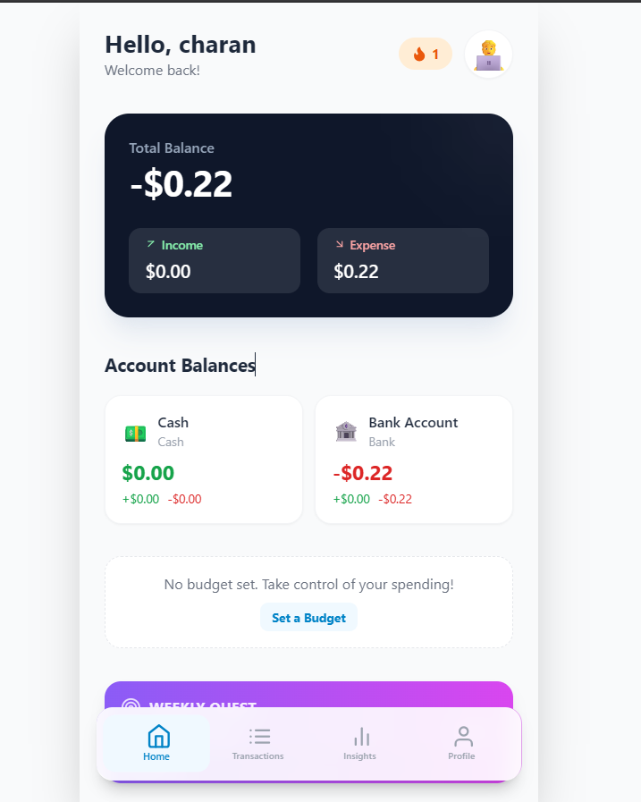

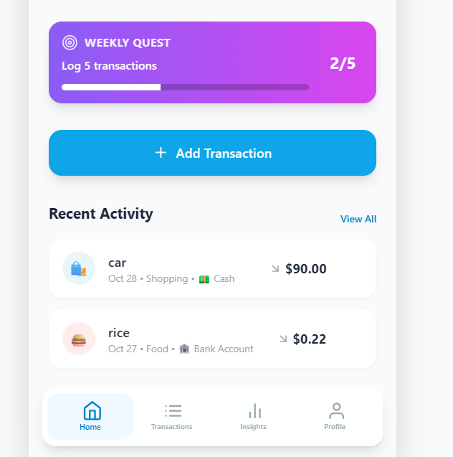
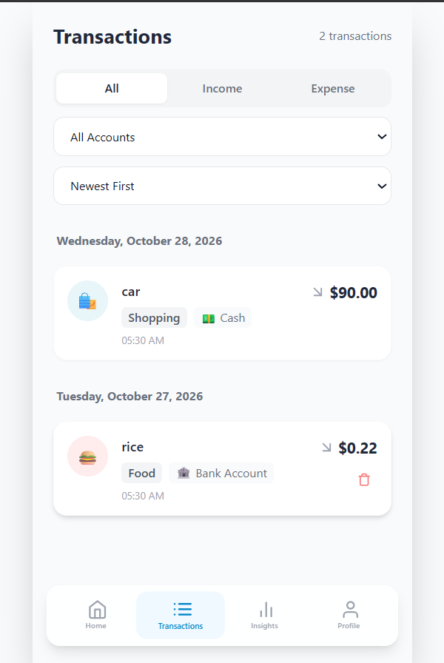

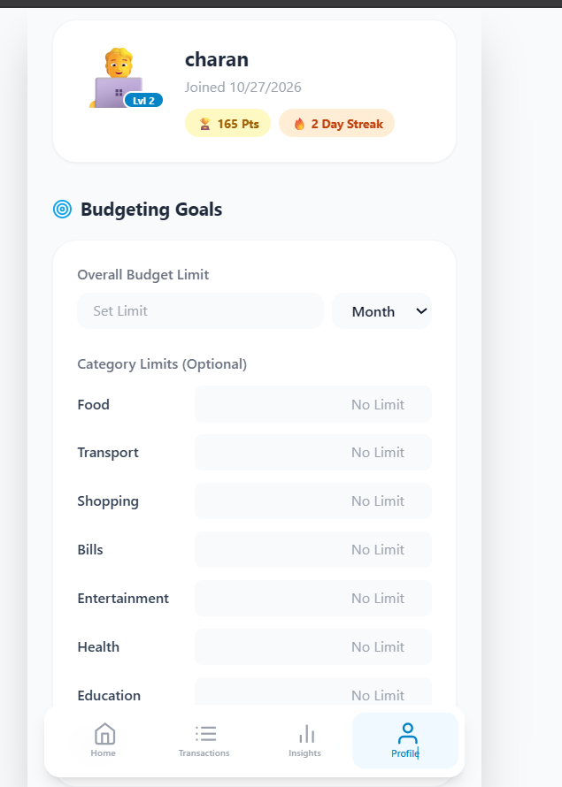
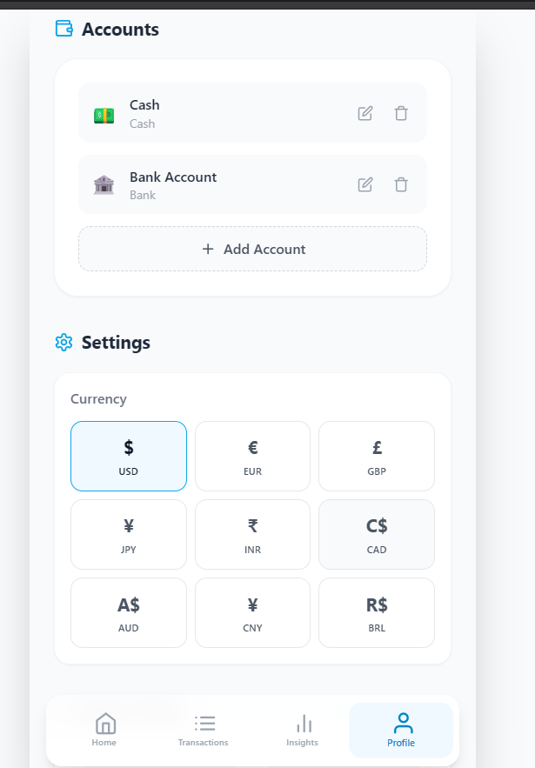

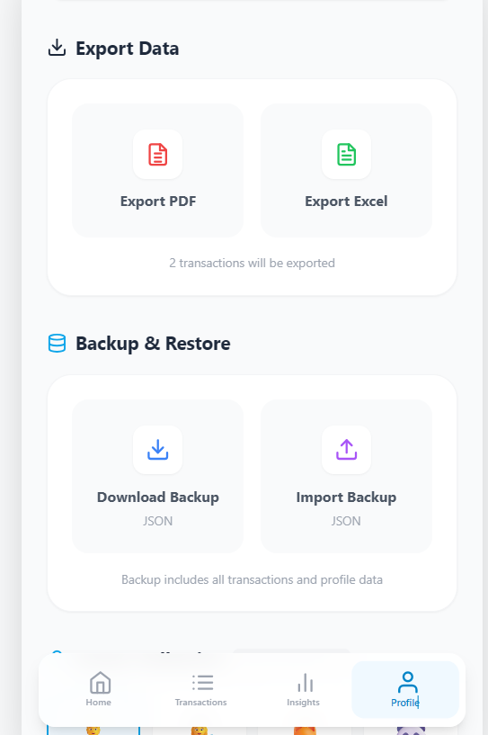

Discussion-
The proposed system combines personal expense tracking, budget monitoring, AI-assisted categorization, and spending analysis. The microservices architecture separates the application's major responsibilities, while REST APIs support communication between components.
The final evaluation should verify the correctness of expense calculations, security of protected operations, accuracy of AI suggestions, and successful integration of services. Quantitative results should be added only after testing has been completed.

- CONCLUSION & FUTURE SCOPE

8.1 Conclusion
The AI-Enhanced Expense Tracking System is designed to simplify personal financial management through a web-based application. It provides facilities for recording, updating, deleting, and viewing expenses, along with monthly spending summaries, category-wise analysis, and budget monitoring.
The project proposes AI-assisted categorization to reduce the effort required to classify transactions manually. Spending insights can help users identify major expenditure categories and understand their financial habits. The use of Spring Boot microservices, REST APIs, JWT authentication, Eureka, and Spring Cloud Gateway provides a modular architecture for the application.
The project also incorporates API testing, security analysis, and CI/CD practices into its planned development workflow. Overall, it demonstrates the potential of combining AI-assisted functionality with microservices to build an organized and maintainable expense management system. The final assessment of the project's success will depend on the features implemented and the results obtained during testing.

8.2 Future Scope
The system can be enhanced in several ways:
- Advanced Expense Prediction: Machine learning models can be introduced to predict future expenditure using historical transaction data.
- Improved AI Categorization: More advanced classification techniques can be evaluated using labelled expense descriptions.
- Personalized Financial Recommendations: The system can generate recommendations based on user-defined budgets and spending patterns.
- Automated Transaction Import: Secure integration with authorized banking or payment APIs could reduce manual data entry.
- Real-Time Budget Alerts: Notifications can be provided when spending approaches or exceeds a predefined budget.
- Mobile Application: A mobile version can improve accessibility and allow users to record expenses on the go.
- Advanced Reports: Downloadable reports and comparisons across months can provide more detailed financial analysis.
- Enhanced Security: Additional measures can improve data privacy, access control, and secure handling of financial records.
- Cloud Deployment: Containerization and orchestration can support scalable deployment and service management.
- Monitoring and Logging: Centralized monitoring and logging can help identify service failures and improve system reliability.

- REFERENCES

The following URLs correspond to the related applications discussed in the literature survey and the technical documentation relevant to your project.
- Walnut — Expense Tracking: https://www.walnut.app/
- Money Manager — Realbyte: https://realbyteapps.com/
- BudgetBakers — Wallet: https://budgetbakers.com/
- YNAB — You Need A Budget: https://www.ynab.com/
- Goodbudget — Budget Management: https://goodbudget.com/
- Expensify — Expense Management: https://www.expensify.com/
- Zoho Expense — Expense Reporting: https://www.zoho.com/expense/
- Splitwise — Shared Expense Management: https://www.splitwise.com/
- Spring Boot Documentation: https://docs.spring.io/spring-boot/index.html
- Spring Cloud Gateway Documentation: https://docs.spring.io/spring-cloud-gateway/reference/

